SEASON 15: 1981-82
Beckenham League Div 4 = L
Beckenham League Cup = BLC
Beckenham Hospital Cup = BHC
Burwood Cup = BC
Friendly = F

F Travaux Utd III 1-3 D.Hammersley
F 16th BBOBA 0-6
F Midland Bank 12th XI 0-2
L Anerley Arms 3-3 M.Vaz, A.St Clair,
B.Daughtry
L Drummond Athletic 3-0 M.Vaz (2) B.Daughtry
BLC Londex Res 5-2 D.Wright (3) B.Daughtry,
K.Foster
L Three Compasses 0-6
L Scotswood Villa 3-2 M.Vaz, D.Wright, K.Foster
BHC Blue Circle 1-2 G.Lattimore
L 16th BBOBA Res 5-0 G.Lattimore (3) Tr Salmon (2)
BC Chislehurst Dynamos 0-8
L Latter Day Saints 5-0 M.Vaz (2) D.Wright (2)
B.Daughtry
BLC Walworth Grove 2-1 M.Vaz, R.Edmonds
L Scotswood Villa 4-1 D.Wright (3) G.Lattimore
BLC Corpus Christi 1-5 D.Wright L Drummond Athletic 4-3 Tr.Salmon (2) D.Wright,
P.Eustace
L Londex Res 7-0 A.St Clair (3) Tr.Salmon (2)
G.Sibley, K.Foster
L Glanville 3-1 A.St Clair (3)
L 16th BBOBA Res 3-2 Tr.Salmon (2) D.Wright
L Three Compasses 1-7 M.Vaz
L Londex Res 4-1 A.St Clair (2) G.Sibley,
B.Daughtry
L Glanville 3-1 A.St Clair (2) D.Ford
L Latter Day Saints 3-1 D.Wright (2) B.Daughtry
F Holdsworth 4-5 B.Chalder, N.Woolhouse,
G.Sibley, G.Lattimore
F Borough Park 4-2 A.St Clair (2) D.Wright (2)
L Anerley Arms 1-1 B.Chalder
F Hilly Fields Res 0-3

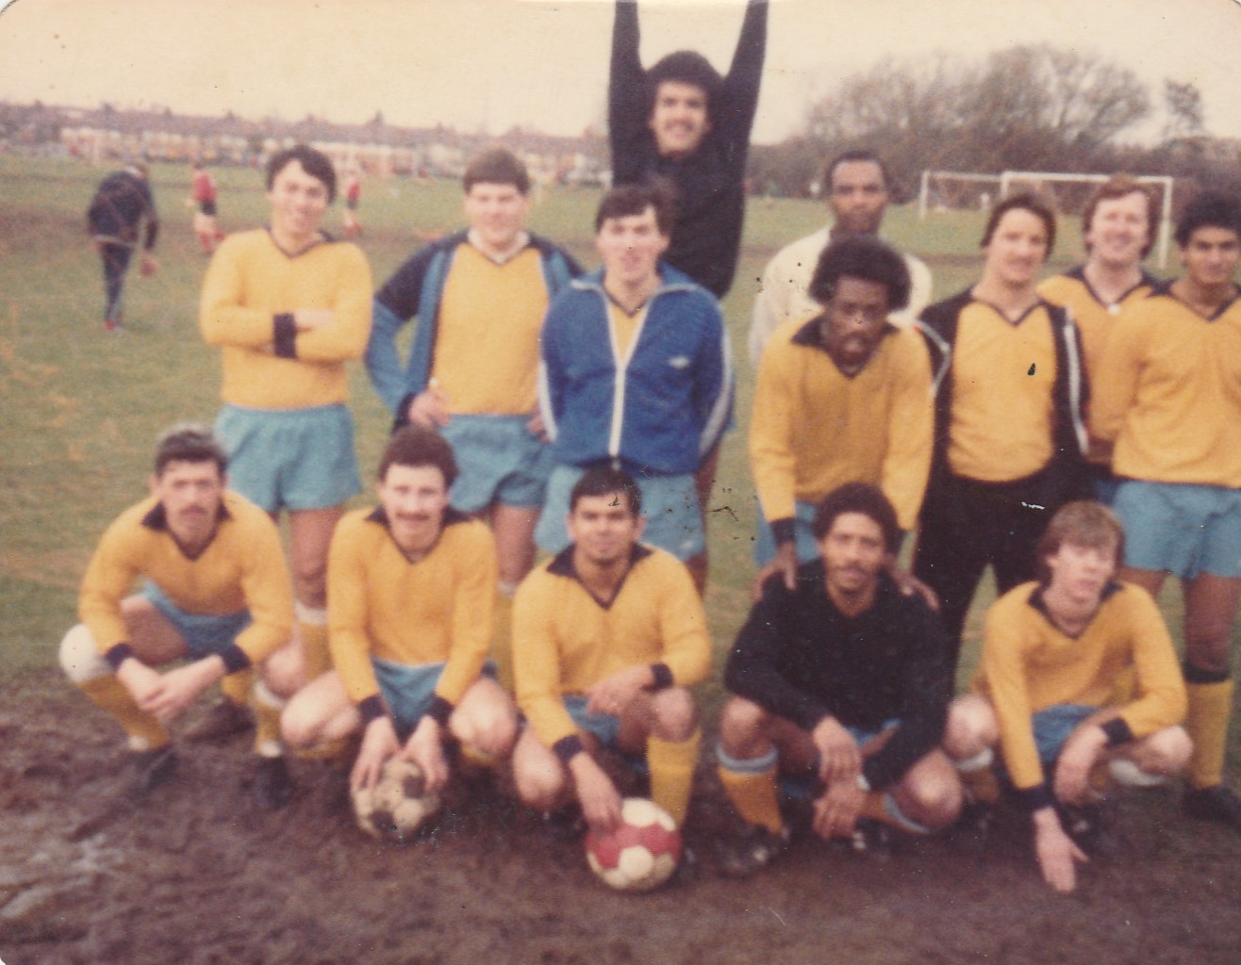

L-R Back:Jimmy Lee, Gary Lattimore, Luis Navarro, Simon Crosskill, Albert St Clair, Trevor Salmon, Bruce Bullen, Robin Edmonds, Winston Vaz,
L-R Front:Dave Wright, George Sibley, Mario Vaz, Vic Banton,
Billy Daughtry

